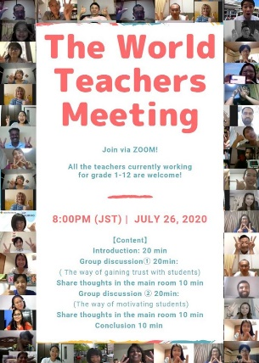
The world teachers meeting.
On Sunday, 26th July, 2020 at 4.45 pm Bangladesh time, 71 teachers from 29 countries of the world came together to discuss how effective the online education system is from the offline education system and what other steps need to be taken for the teachers to acquire professional skills? Almost all teachers around the world have expressed their views on what needs to be emphasized in order to motivate students in all types of education systems. The most notable aspect is that the meeting was divided into Six sessions and the teachers were also given the opportunity to discuss separately. I got many new friends present in that source. After all, I had such a lively afternoon with teachers from 29 countries around the world. Thank you Kumiko for connecting me with you.

