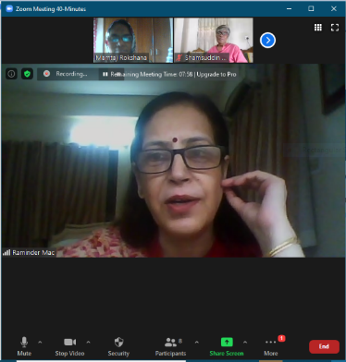
International meeting on education to deal with Covid-19.

On 28th July 2020 at 2.00 pm, we had organized an international meeting between the three countries. India, Pakistan and Bangladesh. The subject of our international meeting was," Is the alternative education system that the Bangladesh government has taken during this epidemic to face the education deficit of students up to international standards, if not, how can it be done?" They joined us in this international meeting from Bangladesh, India and Pakistan. I am mentioning their names below.Dr. Safiul Islam, Deputy Secretary, Government of Bangladesh, present Director, Nectar, Bogra, Mr. Gazi Golam Mawla, Director, Department of Secondary Education and Higher Education, Chittagong Region, Mr. Shamsuddin Ahmed Talukder, Lecturer TT College, Comilla, Mr. Shamsuddin Shishir Lecturer, TT College, Chittagong, Mr. Shaiful Islam Secondary Education Officer, Baruda, Comilla, Mr. Nasir uddin, Principal kumira residential girls school and college, Sitakunda, Chattogram. From India, Raminder Amy Mac​, dean in Choithram School, Indore, India. From Pakistan, Dr Mir Alam Syeed
Ex-Dist Eucation Officer
EX-Professor in Education
Ex-Chairman BoD, College of Education
Workshops Organizer for Elementary, Secondary School Teachers.
Educational Leadership & Management Course Developer
Lead Master Trainer
PhD in Education
MSD Psychology
MA English Literature
MA English Linguistics
MA TEFL
Writer of articles in Pakistani Dailies
And joined us more from Pakistan
Mr Fazal Hanan
Professor in English in HE Dept.
In addition, there are school teachers from different parts of Bangladesh who have been working together for three long months with online live classes as Covid-19 fighters, especially during this Corona period, just to help the students fill the education gap in this difficult time. I am grateful to all of them.
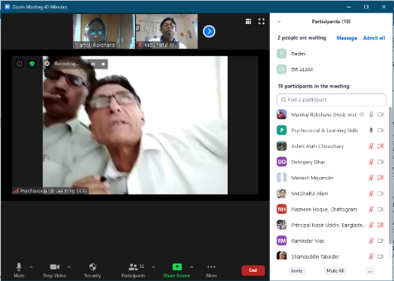
As the host of this meeting, I was able to successfully complete the entire meeting which lasted for about 2 hours. All the issues that we have raised in this meeting are mentioned here, because the answer to every question was to implement SD4 to face the challenges of the 21st century and to create global teachers and students capable of tackling the 4th Industrial Revolution. Also details about the quality of education and the importance of online and offline classes in teacher professional skills and how student friendly they are. Here are the questions, each of which is answered in the video of our negotiators. For the convenience of the readers, I am sharing the videos here. I gave the questions here to understand the topic of discussion in stages:
1. Mr. Gazi Golam Mawla, do you watch our live classes? If you have seen, then briefly say how successful we are in this activity.
2. Indian guest Raminder Amy Mac, how have you kept the education system running in this epidemic? This is my first question. My second question is, which is more effective education system online or offline? Briefly
3. Dr. Safiul Islam, Deputy Secretary, Government of Bangladesh, present Director, Nectar, Bogra
Sir I know you work with SD4, my question is in the implementation of SD4 offline class or online class is important, which one?
4. to Dr. Mir Alam Saeed Sir,
My first question is how your country has kept the education system running in this epidemic? My second question to you is, since you are working as an Educational Leadership & Management Course Developer, what kind of leadership and management power do you think needs to be created in teachers? If so, how is it possible?
5. secondary education officer Mr. Saiful Islam Sir, as a secondary education officer, how confident are you that our online activities are reaching the grassroots level, if not, what should our administration do?
6. Fazal Hannan Sir of Pakistan since you are a teacher of English literature, what is the need of English at all in exchanging language? If so, how can it be firmly established by teachers and students for quality education? Briefly
7. Mr. Shamsuddin Talukder Sir is what would be your advice as a teacher trainer and education researcher to bring quality education and online activities to international standards.
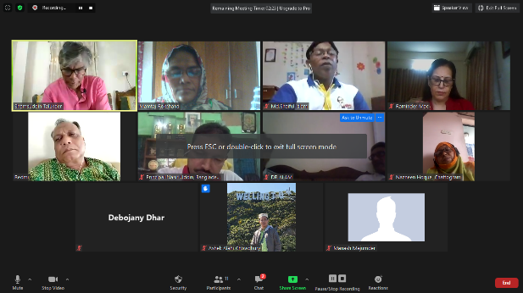
In addition, more speakers discussed how we can move forward with our goals. I believe that if we continue to work, One day we will be successful. Thanks everyone.

