Tale of a visually impaired Girl
Born, as a visual impaired child, Mahfuza Akhter is going to sit for HSC examination this year from Robertsongonj High School & College, Rangpur.
She vowed to continue her study aiming to be an IT specialist defying the challenge in life in her childhood.
Mahafuza passed SSC examination in 2018 scoring 4.08 GPA from Robertsongonj High School & College study center under Bangladesh Open University.
Seeing her eagerness and interest for learning, we always promoted and supported he education, said, Mahafuza’s father, Abdul Malek Sarker, a retired government employee.
Due to my transferrable job, she had to face problems and break off study for some years. If she had continued smoothly, she could have completed her education in the mainstream.
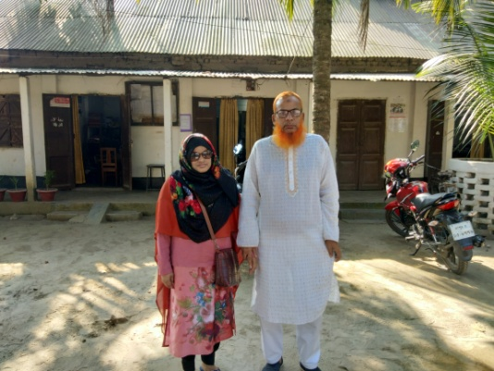

She is the second among the five siblings. Her elder sister is a primary teacher, while the third sister, a MBBS from Salimullah Medical College, fourth sister completed Masters in Bengali literature form National University and the one and only youngest brother is a BSC engineer passed from Khulna University of Engineering & Technology [KUET].
Expressing regret, her mother, Nurunnahar Begum, who was a housewife, said, she is not as usual like her other kids. Her all children completed education and they were brought up naturally. Children participate in games, sports, cultural programs and other activities in everyday life and school routine. But she could not and did not have the opportunities like other children. She had to fight and struggle to reach at this step of the life due to her visual impairment.
Mahafuza said, she does the daily chores at home by herself. She dreamt for education from her early childhood; she chose to be an IT specialist after passing SSC examination. So, she became determined and attentive to her education to reach her goal.
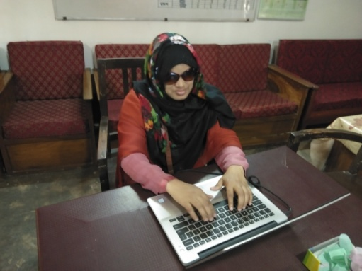

She could not read as usual like other students. She had to read in brail system and attended the examination with the help of a squib. But she does not have any repentation. She is attending the classes and passing the examinations in schools and colleges. Besides, she helps her mother in domestic works.
She also mentioned that there are no specialized schools for blind learners in the country. So, she had to join the mainstream educational institutes for her education. If the audio contents are available for learning, the visually impaired students would be benefitted. It’s really very tough for a blind child to continue study in the conventional school and colleges. But she could manage somehow.
Teachers, staffs and friends in schools and college are very caring and friendly to her. So, she gathered courage, confidence and could continue.
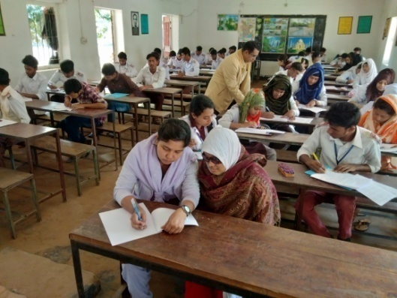

She is currently working as a volunteer in an online based school for visual impairment - School of Mind light in Dhaka, the First ever school in Bangladesh ICT based.
She loves to read science fiction and enjoy music – Rabindra sangeet in her leisure time. She joined the face book in 2017 and lot of friends with whom she used to maintain communication and relations.
She expressed her thanks and gratefulness to the Almighty Allah to bring her at this step of life. ‘I am really indebted to my parents and family members; for their endless mental support despite the many obstacles’. I also felt my gratitude to the people especially, teachers and friends who have inspired me throughout the years with support and care’.
Abul Khair Mohammad Masum, a lecturer in English, who teaches Mahafuza, said, a significant number of children with disabilities does not get access the educational facilities due to lack of specialized schools in our country. Mainstream school is not always able to meet the demands of the disabled children. They need special caring, attention and environment. Teachers need to be trained to handle the students. We, however, took care of her despite of our limitations.
Principal, Zakir Hossain said, teacher-student ratio is usually very high in mainstream schools. It often becomes difficult for the teacher to manage the normal students let alone disabled. The blind students need special educations of Braille for which teachers need special training. It’s very difficult to teach blind students in the mainstream educational institutes. Due to absence of school for visually impaired children, Mahafuza had to join the mainstream inclusive education. She had a strong will for education. She had intelligence and talent. We just tried to take care of her.
Educational and information technology can also play an important role to create a congenial environment for the special child. A blind child not only needs education but also needs proper guidance to lead his life, he mentioned.
A Statistical data shows that more than 39 million in the world are bereft of vision. Blindness is one the major health care problems in Bangladesh and it very prevalent among children which is a 0.75 per 1000 children (WHO) according to global estimates. So there is about a population of 40000 blind children in Bangladesh. Most of them live in the rural areas and are deprived of education.
We can know many success stories of physically challenged people across the world. As , there is a little scope of education for special child in our country, the government can take measures formulating policies of special education in the mainstream educational institutes for the handicapped children ensuring a congenial atmosphere .

Zakir Hossain
Principal
Robertsongonj High School & College
Alamnagar. Rangpur
zakir63283@gmail.com

