Celebration of Earth Day staying at Home:
On the occasion of Earth Day, the students of English Access, a micro scholarship program funded by U. S. Department of State under the banner of GEIST International Foundation set a unique example of creative works highlighting the theme ‘Climate Action’ of this year.
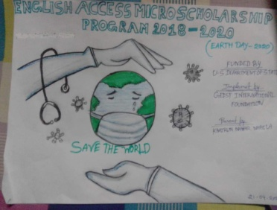

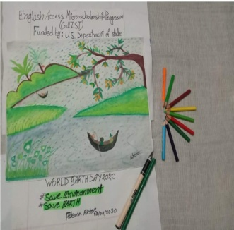
April 22nd, 2020 marks the 50th anniversary of Earth Day, the annual celebration of the environmental movement. About 20 million Americans took to the streets pressing for greater attention to make the planet better and more livable. People experienced how badly the environment of the earth was being contaminated. They felt the need to protect the nature. Since then the activists around the world gather each year to mark the day.

Earth Day is now observed globally, and a good number of countries also celebrate Earth Week to focus on environmental issues. Countries across the globe observed Earth Day, with this year's theme being "Climate Action".
Bangladesh is one of the most vulnerable countries to climate change. Bangladesh ranked as the seventh country most affected in the world due to ‘extreme weather events’ over the last 20 years in 1998-2017, said a new global report. So, we need to take up this event with a more proactive role.
Ironically, this year’s Earth Day takes place amid the most widespread and deadly pandemics, the world has ever seen. Schools, Colleges, shops, markets, government and non-government organizations remained shutting. Any gatherings, meetings and events have been strictly prohibited — but that doesn’t mean that none can observe the Earth Day occasion staying at Home.
The English Access students of micro scholarship program who are mostly underprivileged observed the day in a unique way. The age group of the students is 13-16 who read in different vocational institutes under Bangladesh Technical Education Board. GEIST International Foundation with the support of US department of state runs a two months language learning course - English Access, a micro scholarship program for them aiming to develop their global language skill.
Staying at home during the Pandemic corona days the students drew some wonderful paintings in which they showed love and responsibility for nature. They wanted to create awareness and inspire others to think about our mother nature in their paintings.
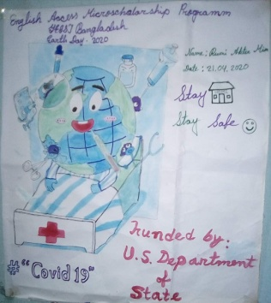

A teacher of Mi English Access, a micro scholarship program Mohammad Shahed Ali said, these underprivileged students did unique job to celebrate the day staying at home during the pandemic. They drew creative paintings in which they tried to send a message to all to Save the Earth on the occasion of Earth Day.
He also told that last year on the Earth Day, the students went to Ramna Park and organized a rally in order to raise awareness and love for nature among the people. They cleaned up the dust, dried leaves, waste and garbage in the park.
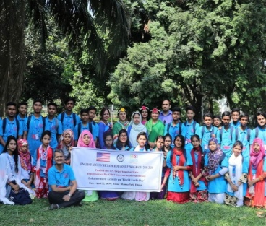

They distributed leaflets, posters and festoons in the park to create a sense of awareness and responsibility towards nature among the visitors of the park. The students also became familiar with different species of plants at the park and ‘Know the Species'.
A student of the Access Program, Meherun Nesa said, we are the child of the Earth. So, we have responsibilities to take care of the Earth and the people. The world is running through a very difficult and troubled time. Numerous restrictions were imposed around movement and public in gathering. We made a slogan this year- Maintain social distance / Help others/ Save the Earth from Corona/ Stay Home, Stay Safe. We urged the people to maintain social distance, help others and Stay at Home in order to fight Covid 19 in the paintings in observance of the Earth Day this year.

Zakir Hossain
Principal
Robertsongonj High School & College
Alamnagar. Rangpur
&
Deputy Regional Director
GEIST International Foundation

