Pakistan shuts schools to curb new coronavirus infections
Published : Friday, 27 November, 2020 at 11:37 AM Count : 76
Observer Online Desk
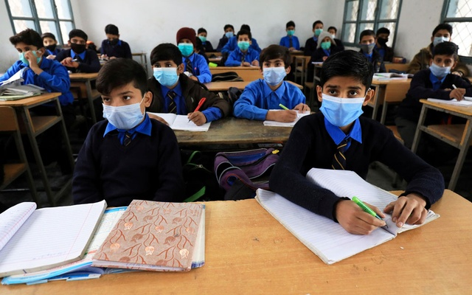
Students wear protective masks as they attend a class at school as the outbreak of the coronavirus disease (COVID-19) continues, in Peshawar, Pakistan November 23, 2020. Photo: Reuters

Pakistan shut its schools and postponed exams on Thursday to try to curb new coronavirus infections and a rise in the number of people in hospital with COVID-19.
Students, including those at higher educational institutions as well as in private schools, are expected to continue classes through distance learning until December 24, when schools are scheduled to go on winter break until January 11.

"All efforts will be made to make sure that education continues from home," Education Minister Shafqat Mahmood said on Monday, announcing the closure of schools, adding that "if the situation improves" schools would reopen on January 11.
Pakistan reported 3,306 new cases on Wednesday, and 40 deaths from the pandemic, with 2,485 patients currently admitted in hospitals, according to officials. There have been 386,198 total cases in the country recorded so far, and 7,843 deaths.
The decision to close schools, officials have said, was based on an increase in the rate of positive test results in the country. The rate of people testing positive in June was as high as 23%, but dropped to a low of 1.7% by September. It has since begun to increase again, reaching 7.41% this week.
More than 19% of new cases were from educational institutions, where the rate of positive results had nearly doubled in one week to reach 3.3%, officials said on Monday.
The south Asian country has ruled out a wide ranging lockdown, opting to close down non-essential public gatherings in a bid to keep the economy afloat through the pandemic.
"We do not know what this winter is going to be like, so there is a bit of worry right now because our cases are rising up quite rapidly these days," Prime Minister Imran Khan told an event organised by the World Economic Forum on Wednesday.

"We are going to only lock down the non essential, in other words the public gatherings and so on where our economy doesn't get hurt."

Pakistan closed educational institutions between March and September to combat the spread of the virus. State television and radio stations were used to broadcast lessons for students at home for students in government schools.

