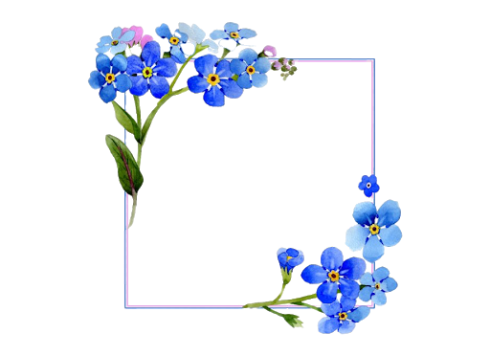
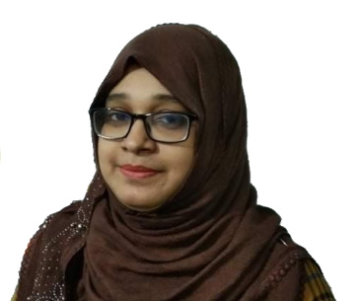
You are Mine
Ayasha Nahar Hossain

You are the one
Whom I can show my tear,
You are the one who know my fear…
You know when I smile
You know the reason of my happiness.

In your eyes I can see my dreams.
In your arms maybe I can feel my peace.

I wish to fly in the sky
By holding your hands.
Want to see the moonlight
Hope to enjoy a day on a beach.

I want to die with you
Want to live with you too.

But I can’t.
I can’t hold your hand,
Can’t even say you anything.
But I can imagine that
You are only mine
And I mean it.
Ayasha Siddiqua

