In new summit, Biden seeks 'free and open' Pacific with Australia, India, Japan

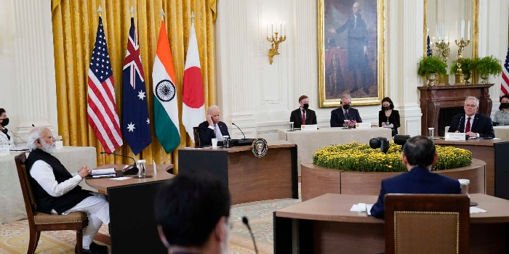
In new summit, Biden seeks 'free and open' Pacific with Australia, India, Japan

President Joe Biden and the leaders of Australia, India and Japan promised Friday to work together for a stable, open and democratic Indo-Pacific in a veiled dig at China during their first in-person summit together, reports AFP.
In Biden's latest effort to cement US leadership in the face of a rising China, the so-called Quad agreed to move ahead on a joint plan to provide Covid-19 vaccines around Asia, launched a new climate initiative and said the four nations would begin holding annual summits.
Without any explicit mention of China, the leaders of the four democracies in a joint statement said they were committed to "promoting the free, open, rules-based order, rooted in international law and undaunted by coercion."
"We stand for the rule of law, freedom of navigation and overflight, peaceful resolution of disputes, democratic values and territorial integrity of states," they said.
"Free and open" has become code for expressing worry about swelling Chinese economic, diplomatic and military presence -- including threats to vital international sea lanes.
Australian Prime Minister Scott Morrison, speaking as the talks opened, said that the four "liberal democracies" were working to build a "strong, stable and prosperous region."
Japanese Prime Minister Yoshihide Suga said the summit showed the four nations' "common vision of a free and open Indo-Pacific," while Indian Prime Minister Narendra Modi -- whose own track record on minority rights has been controversial at home -- hailed the Quad's "shared democratic values."
While the leaders carefully avoided public mention of China, Suga voiced "strong concern" during the talks about Beijing's assertiveness at sea, its trampling of Hong Kong's special status and its mass incarceration of the Uyghur minority, Japanese foreign ministry spokesman Tomoyuki Yoshida said.
- Showing action on vaccines -
Biden, who often talks about democracies needing to prove their capability in an age of powerful autocracies in Russia and China, sought to show the Quad was about action.
"We're four major democracies with a long history of cooperation. We know how to get things done and we are up to the challenge," he said.
India said it would export eight million one-dose Johnson & Johnson vaccines by the end of next month.
"This is an immediate delivery from the Quad into the Indo-Pacific region," Indian Foreign Secretary Harsh Vardhan Shringla told reporters, vowing to supply "quality and affordable" vaccines.
While modest in number -- Biden promised earlier this week that the US would donate an extra 500 million doses to the world -- it represents the return of India's giant pharmaceutical industry after New Delhi stopped exports to handle the country's own severe Covid outbreak.
During virtual talks in March, the Quad leaders said they would supply more than one billion vaccines by the end of 2022, with India providing production, Japan and the United States financing and Australia the logistics.
On another key priority for Biden, the Quad leaders said the four nations would all make "ambitious" announcements at the upcoming Glasgow climate summit with an aim of bringing the warming planet to net zero emissions by 2050.
India has so far only committed to reducing its carbon intensity, not necessarily its emissions, arguing that sweeping cuts are unrealistic for an emerging economy that is not historically responsible for most of the world's warming.
In one key area of work, the Quad leaders said they would set up a task force to work to slash emissions by 2030 in shipping, coordinating among the key ports of Los Angeles, Mumbai, Sydney and Yokohama.
- No military component -
India has been the most cautious about perceptions it is ganging up on China despite mounting tensions following deadly border skirmishes last year.
US officials stressed that they did not see the Quad as a military alliance even as they sought to broaden cooperation.
The United States just last week announced another alliance -- AUKUS -- with Australia and Britain that will include sharing of sensitive nuclear technology.
Under AUKUS, Australia will acquire nuclear-powered submarines. Although delivery is years away, the announcement sent waves around the world, angering China and separately causing a furious row with France which saw its previously negotiated contract for selling Australia conventional submarines thrown out.
Morrison called the Quad a "very practical initiative" but said it was part of building "a region that we wish to be always free from coercion."
SZA

